**ASSIGNMENT JVM1**

**Chirag Kumar Sharma**

1.)Write a program to replace a substring inside a string with other string ?

Initial String : My name is Chirag.

Output String : My name is Abhishek.

“Chirag” replaced with “Abhishek”

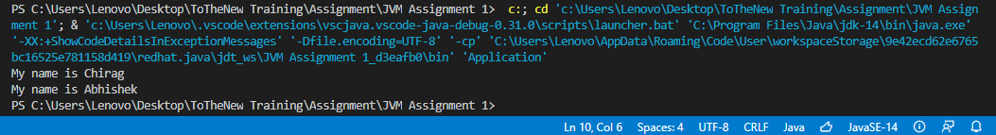

2.)Write a program to find the number of occurrences of the duplicate words in a string and print them ?

Occurrence of every duplicate word in ”he is Chirag and he is learning to code and he is training in TOTHENEW”

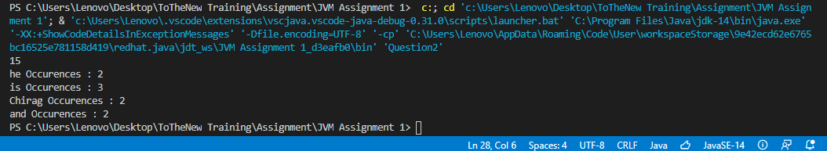

3.) Write a program to find the number of occurrences of a character in a string without using loop?

Number of Occurences of “i”, in the sentence “MY name is Khan and I am not a terrorist”.

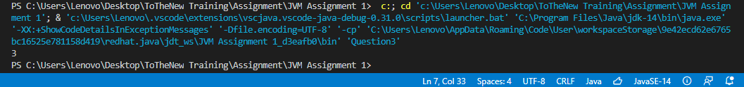

4.)  Calculate the number & Percentage Of Lowercase Letters,Uppercase Letters, Digits And Other Special Characters In A String.

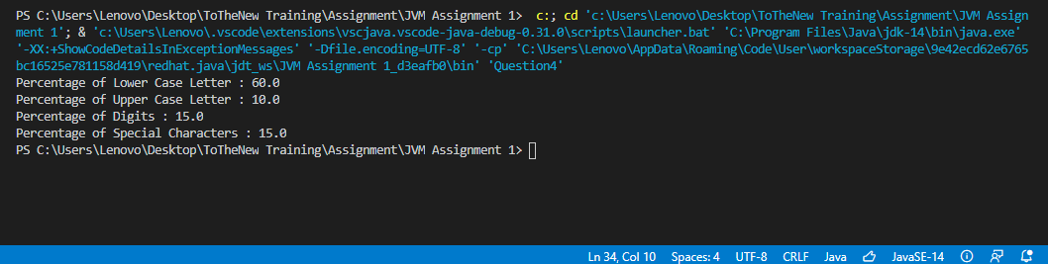

5.) Find common elements between two arrays.

Common elements between int[] array1 = {1, 2, 5, 5, 8, 9, 7, 10};

int[] array2 = {1, 0, 6, 15, 6, 4, 7, 0};

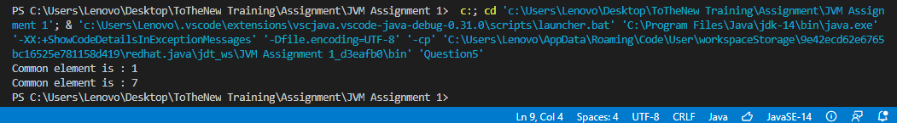

6.) There is an array with every element repeated twice except one. Find that element

Single Occurred element in the array {1,1,2,2,3,4,4}

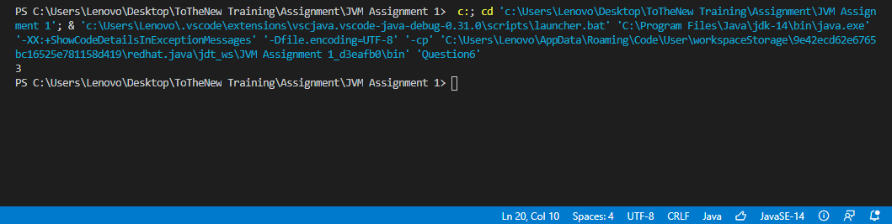

7.) Write a program to print your Firstname,LastName & age using static block,static method & static variable respectively

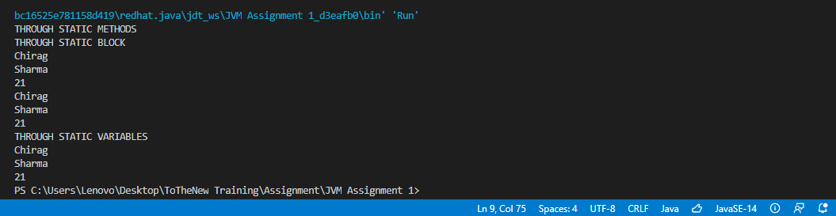

8.) Write a program to reverse a string and remove character from index 4 to index 9 from the reversed string using String Buffer.

Initial String : “Yes OR no OR Yes”

Changed to seY RO seY after reversing and removing elements from 4 to 9.

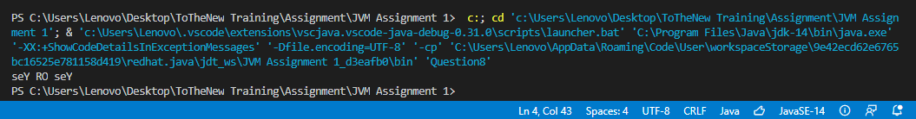

9.) Write a program to display values of enums using a constructor & getPrice() method (Example display house & their prices)

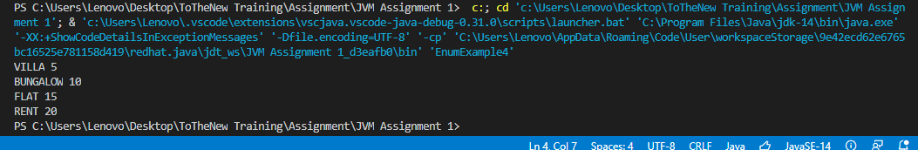

10.) Write a single program for following operation using overloading  
  A) Adding 2 integer number  
  B) Adding 2 double  
  C) multiplying 2 float  
  D) multiplying 2 int  
  E) concate 2 string  
  F) Concate 3 String

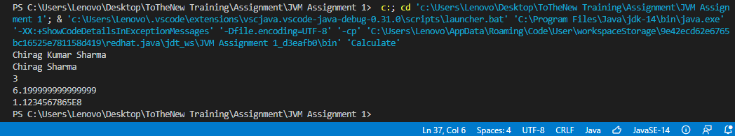

11.) Create 3 sub class of bank SBI,BOI,ICICI all 4 should have method called getDetails which provide there specific details like rateofinterest etc,print details of every banks

Displays details of Bank name, Rate of interest and branch.

